2025 SEAS Business Membership

COMPANY _____________________________________________________

CONTACT _____________________________________________________

ADDRESS _____________________________________________________

_____________________________________________________

PHONE _____________________________________________________

EMAIL _____________________________________________________

***DUES FOR 2024 ARE *$300* FOR BUSINESS MEMBERS***

Please return this form along with payment to:

SEAS



PO Box 6238

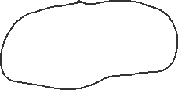

Ketchikan, AK 99901

You can also log onto our web site and pay via pay pal credit card at:

<https://www.seiners.net/membership/>