Become a Member Today! Southeast Alaska Seiners
https://www.seiners.net/membership/ Association
PO Box 6238
Ketchikan, AK 99901
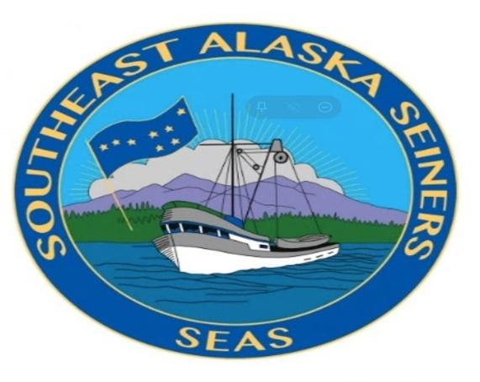

2026 SEAS Membership

The Southeast Alaska Seiners Association is once again asking your business for continued support. Your business has been a regular contributor to SEAS in past years and we greatly appreciate your support.

SEAS is the preeminent local, species specific, regionally based commercial fishing association in Alaska with focus on Pacific Salmon Treaty, Board of Fisheries issues, Marketing Funding, Fleet Consolidation, Regulatory and Administrative Access to SE Salmon Resources and Conservation Principles.

The issues our industry faces have become increasingly complex and time consuming. SEAS is working hard to ensure a future for the commercial seine fleet.

SEAS is a non-profit organization funded solely through membership dues. You can support us by becoming a member. Membership dues are partially tax deductible.

Membership dues can be paid in two ways, either a check made out to SEAS and sent to PO Box 6238, Ketchikan, AK 99901, or log on to our web site and use our online payment option.

SEAS cannot continue its mission without your help. Thank you for your support.

Sincerely,

Phil Doherty – Executive Director https://www.seiners.net/membership/

